Floor Level Material Transfer Mobile Robot
21MHPXXXL - MAJOR PROJECT REPORT

Submitted by

Lalithesh K (RA2211038010007)
Tejas M K (RA2211038010012)
Preetham M (RA2211038010046)
(Batch No.: MHRP 02)

Under the guidance of
Dr. R. Senthilnathan M.E., Ph.D.
(Professor, Department of Mechatronics Engineering)

In Partial Fulfilment for the Degree
of
BACHELOR OF TECHNOLOGY
in
MECHATRONICS ENGINEERING (Robotics)
of
COLLEGE OF ENGINEERING & TECHNOLOGY
S.R.M. Nagar, Kattankulathur, Kancheepuram District

May 2026

SRM INSTITUTE OF SCIENCE AND TECHNOLOGY
(Under Section 3 of UGC Act, 1956)

Bonafide Certificate

Certified that this project report titled "Title of the Project" is the bonafide work of
“Lalithesh K (RA2211038010007), Tejas M K (RA2211038010012) and Preetham M (RA2211038010046)” who carried out the project work under my supervision. Certified further, that to the best of my knowledge the work reported herein does not form part of any other project report or dissertation on the basis of which a degree or award was conferred on an earlier occasion on this or any other candidate.

SIGNATURE

Dr. R. Senthilnathan M.E., Ph.D.
GUIDE
Assistant Professor
Dept. of Mechatronics Engineering

Signature of the Internal Examiner

SIGNATURE

Dr. T. Muthuramalingam, M.E., Ph.D.
PROFESSOR & HEAD OF THE DEPARTMENT
Dept. of Mechatronics Engineering

Signature of the External Examiner

Abstract

This project presents the design and development of an autonomous indoor delivery robot capable of transporting materials between designated locations on a single floor of a building. The system brings together mechanical, electronic, and software subsystems into a unified platform that supports reliable navigation within a structured corridor-based environment.

Localization is achieved using a pre-built occupancy grid map of the deployment floor in combination with onboard sensing and perception. The robot continuously estimates its pose and applies path planning algorithms to determine collision-free routes between assigned source and destination points. Global and local planning are used in combination, where the global planner computes an overall route and the local planner handles dynamic adjustments and obstacle avoidance during execution.

Velocity commands generated by the control system drive the robot along the planned path, providing precise motion control throughout operation. The system is designed to function safely alongside building occupants, with continuous environmental monitoring allowing the robot to respond to changes and dynamic obstacles in real time. A user interface allows operators to assign pickup and dropoff tasks and track mission status during operation.

The complete system was validated through structured integration testing and real-world trials, confirming reliable performance across navigation, obstacle avoidance, and task execution under deployment conditions. This work demonstrates a practical implementation of autonomous indoor robotics for logistics and material delivery in institutional environments.

Acknowledgements

It has been a great honor and privilege to undergo B.Tech in Mechatronics at SRM Institute of Science and Technology. We are very much thankful to the Department of Mechatronics, SRM Institute of Science and Technology for providing all facilities and support to meet our project requirements.
We would like to thank our Head of Department Dr. T. Muthuramalingam, M.E., Ph.D. and our project guide Dr. [Guide Name], M.E., Ph.D. who gave us a big helping hand during the entire project.
The success and final outcome of this project required a lot of guidance and assistance from many people and we are extremely fortunate that we have got this all along the completion of our project work. Whatever we have done is only due to such guidance and assistance and we would like to thank them for their kind support.

Lalithesh K
Tejas M K
Preetham M

Table of Contents

CHAPTER NO. TITLE PAGE NO.
ABSTRACT iii
ACKNOWLEDGEMENTS iv
TABLE OF CONTENTS v
LIST OF TABLES vi
LIST OF FIGURES vii
LIST OF ABBREVIATIONS viii
LIST OF SYMBOLS ix

1 INTRODUCTION 1
1.1 Background of the Project 1
1.2 Challenges in Existing System 3
1.3 Applications 4
1.4 Need of the Project 5
1.5 Methodology (Block Diagram) 6
1.6 Organisation of the Report 7

2 LITERATURE SURVEY 9

3 [CHAPTER TITLE – GUIDE'S DECISION] 13
3.1 [Sub-heading 1] 13
3.2 [Sub-heading 2] 15
3.3 [Sub-heading 3] 17

4 [CHAPTER TITLE – GUIDE'S DECISION] 20
4.1 [Sub-heading 1] 20
4.2 [Sub-heading 2] 22
4.3 [Sub-heading 3] 24

5 [CHAPTER TITLE – GUIDE'S DECISION] 27
5.1 [Sub-heading 1] 27
5.2 [Sub-heading 2] 29

6 CONCLUSION AND SCOPE FOR FUTURE WORK 33
6.1 Conclusion 33
6.2 Scope for Future Work 34

REFERENCES 35
APPENDIX A – [Title] 38
APPENDIX B – [Title] 50

List of Tables

TABLE NO. TITLE PAGE NO.

Table 3.1 [Table Title] XX
Table 3.2 [Table Title] XX
Table 4.1 [Table Title] XX
[Add more table entries as needed]

List of Figures

FIGURE NO. TITLE PAGE NO.

Figure 1.1 [Figure Title] XX
Figure 3.1 [Figure Title] XX
[Add more figure entries as needed]

List of Abbreviations

ABBREVIATION FULL FORM
ABBR 1 [Full form of abbreviation 1]
ABBR 2 [Full form of abbreviation 2]
ABBR 3 [Full form of abbreviation 3]
ABBR 4 [Full form of abbreviation 4]
ABBR 5 [Full form of abbreviation 5]
[Add all abbreviations used in the report in alphabetical order]

List of Symbols

SYMBOL DESCRIPTION
F [Description of symbol F]
P [Description of symbol P]
Q [Description of symbol Q]
n [Description of symbol n]
σ [Standard deviation or as applicable]
μ [Dynamic viscosity or as applicable]
η [Efficiency or as applicable]
[Add all symbols with their units/descriptions]

Chapter 1 Introduction

1.1 Background of the Project
Autonomous mobile robots have seen growing deployment across structured indoor environments — hospitals, warehouses, academic institutions, and office buildings. These systems are designed to carry out tasks such as material transport, delivery operations, and logistical assistance, reducing dependency on manual labour and improving the efficiency of routine workflows. Indoor navigation, therefore, forms one of the most foundational technical requirements for any such robotic system to function usefully in practice.
A core difficulty in indoor environments is the absence of global positioning infrastructure. Unlike outdoor deployments, robots operating inside buildings cannot rely on satellite-based localization, and must instead determine their position using onboard sensing alone. This has led to the widespread adoption of map-based navigation, where the robot maintains a spatial representation of its operating environment and uses it as a reference frame for all motion-related decisions. Among the various representation schemes available, the occupancy grid map has become the most commonly used format in practice. In this approach, the floor plane is divided into a uniform grid of discrete cells, with each cell assigned a state indicating whether it is free or occupied. This representation integrates naturally with standard range-based sensors and is directly supported by widely used navigation frameworks.
Localization — the process of estimating the robot's pose within a known map — is a central component of any navigation pipeline. In deployed systems, this is typically achieved using onboard sensors such as stereo cameras, depth sensors, or inertial measurement units, which provide continuous information about the robot's motion and immediate surroundings. By comparing sensor observations against the pre-built map, the system maintains a running estimate of position and orientation, which is then used to drive path planning and motion control decisions.
Indoor navigation systems generally follow a structured operational pipeline. After the robot establishes its current position within the map, it computes a collision-free trajectory to the specified goal location. This trajectory is continuously revised as the robot moves, incorporating updated sensor data to account for changes in the environment. The process must function reliably in the presence of dynamic elements — people moving through corridors, temporarily placed obstacles, partially open doors — all of which introduce uncertainty that the system must handle without degrading navigation performance or compromising safety.
The two principal approaches adopted in existing indoor navigation systems are simultaneous localization and mapping, commonly referred to as SLAM, and navigation against a pre-built static global map. SLAM-based systems build a map incrementally as the robot explores its environment, estimating pose and map structure jointly in real time. While this eliminates the need for a prior survey, it introduces substantial computational overhead and is sensitive to sensor noise — particularly in large or geometrically repetitive indoor environments such as long corridors with similar-looking segments, where data association errors can accumulate and degrade both map quality and localization consistency. Systems that navigate against a pre-built global map sidestep these issues by treating the map as a fixed reference, reducing runtime complexity and providing more consistent localization behavior. However, this approach typically loads and operates on a single monolithic map throughout the navigation session, regardless of the robot's actual position within the environment.
Both approaches perform adequately for small to medium-scale environments, but encounter meaningful limitations when applied to larger indoor spaces. The core issue with a monolithic map representation is that the navigation system processes the entire map at all times, independent of the robot's current location. In corridor-based environments — where the navigable area constitutes only a fraction of the total floor footprint — this means that substantial computational and memory resources are spent on regions of the map that are structurally inaccessible and have no relevance to the robot's immediate navigation context. Path planning, costmap maintenance, and localization all operate over the full map extent, resulting in resource usage that scales with total environment size rather than with the area actually relevant to the current task.
This scaling behavior is a practical concern on the class of embedded computing platforms commonly used in mobile robotics. Platforms such as the NVIDIA Jetson Nano impose firm limits on available RAM and CPU throughput, while simultaneously running sensor drivers, localization algorithms, and communication stacks alongside the navigation components. Under a monolithic map approach, as the environment grows, the navigation stack's footprint grows proportionally, consuming an increasing share of the available compute budget and leaving less margin for other processes. At building scale, this can push resource utilization to levels that compromise real-time responsiveness.
The approach taken in this work addresses these limitations through a fundamentally different map management strategy. Rather than relying on a single global map loaded in its entirety, or performing real-time mapping during operation, the system operates from a pre-built map that has been partitioned offline into a set of spatially contiguous segments. At runtime, only the segment corresponding to the robot's current location is held in active memory. Transitions between segments are handled through a switching mechanism that loads the relevant segment as the robot moves across zone boundaries, keeping the active map footprint bounded to a per-segment constant regardless of total floor size. This approach retains the consistency advantages of a pre-built map while making memory and compute usage independent of global environment extent.
Corridor-based indoor environments have a structural property that makes this approach particularly well-suited. The navigable space in such environments is geometrically narrow — the robot moves through pathways while the surrounding area, comprising walls, room interiors, and structural elements, is entirely non-traversable. Despite this, a monolithic map allocates equal representation to all cells, navigable or not. The navigation stack builds data structures over the full grid extent, including the large majority of cells that the robot will never occupy. In a floor map at standard navigation resolution, this mismatch between represented area and actually navigable area can mean that well over eighty percent of costmap resources are spent on space that contributes nothing to navigation. Partitioning the map along navigable zone boundaries, rather than along the geometric bounding box of the environment, directly eliminates this inefficiency.
Beyond the navigation stack itself, real-world deployment requires a functional interaction layer between the operator and the robotic system. A user interface allows operators to assign delivery tasks, specify pickup and drop-off locations, and monitor the robot's operational status. This layer is not incidental to the system's function — in a service robotics context, it is what enables the robot to be directed toward useful work by non-specialist users, and what provides visibility into system behavior during operation. The design of this interface layer must therefore be considered alongside the navigation architecture as part of a complete deployment-ready system.
As deployment environments scale beyond single rooms to full building floors, the limitations of conventional single-map navigation approaches become increasingly tangible. Memory overhead, computational load, and the structural inefficiency of representing large non-navigable regions all compound with environment size, motivating map management strategies that are more closely aligned with the actual navigable topology of the environment. These considerations form the basis for the approach described in the sections that follow.

1.2 Objectives
The objective of this work is to develop an efficient and scalable autonomous indoor delivery system for a mobile robot operating within a structured building environment — specifically the second floor of the Hi-Tech Block at SRMIST KTR. Environments of this type are characterised by well-defined spatial layouts consisting of corridors, room entrances, and structurally restricted regions. Navigating such spaces reliably requires accurate pose estimation, collision-free path execution, and consistent sensor-based operation under real-world conditions. The system is designed to enable autonomous material transfer between designated locations on the floor while maintaining predictable performance across the full range of operating scenarios encountered in a populated academic building.
The work is motivated by practical limitations in conventional indoor navigation approaches. Systems that rely on a single monolithic global map load and process the entire environment representation throughout operation, regardless of where the robot currently is. This leads to memory usage and computational load that scale with total floor size rather than with the region the robot is actually navigating. SLAM-based alternatives avoid the need for a pre-built map but introduce substantial real-time processing overhead and are susceptible to drift in geometrically repetitive environments such as long uniform corridors. Neither approach is well-matched to embedded platforms with fixed resource budgets operating across building-scale spaces. The present work addresses these limitations through a pre-built map management strategy that constrains active memory usage to the robot's current navigable zone, improving computational efficiency and system reliability without sacrificing localization consistency.
To achieve this, the following specific objectives are defined:
Localization on a Pre-built Map: To implement robot localization using onboard sensors against a pre-constructed occupancy grid map of the deployment environment, enabling accurate and consistent pose estimation during operation without the need for real-time map generation. The target localization accuracy is 15 cm, sufficient for corridor-level navigation and room-entrance delivery tasks.
Efficient and Reliable Navigation: To develop a navigation framework capable of generating collision-free global paths and executing them through a local controller, providing consistent path-following performance across all navigable zones of the floor. This includes cross-tile path planning, where the robot's goal lies within a different map tile than its current location, requiring the navigation stack to coordinate tile transitions with ongoing path execution.
Safe Operation in Dynamic Environments: To ensure reliable operation in the presence of dynamic obstacles and human activity, which are inherent to shared indoor spaces. The system employs a stall-and-alert strategy for dynamic obstacle handling — the robot halts and issues an audio alert when a human blocks its path, rather than attempting real-time replanning around moving people. This approach prioritises predictable, safe behaviour over aggressive replanning near humans, reducing the risk of unsafe interactions.
User Interface for Task Interaction: To provide an accessible interface through which operators can assign pickup and drop-off tasks and monitor the robot's operational status during delivery runs. The interface is intended for non-specialist users and must support real-time task submission and status feedback without requiring direct access to the robot or its software stack.
Developer Dashboard and System Monitoring: To design a separate developer-facing dashboard that provides remote monitoring capabilities, manual pilot control via joystick, live map and pose visualisation, and system diagnostics. This dashboard supports maintenance workflows, environment remapping, and performance evaluation without interrupting normal delivery operations.
Modular and Scalable System Design: To establish a modular software architecture in which individual components — map tiles, navigation configuration, task management, and user interface — can be updated or extended independently. In particular, the tile-based map structure should allow new floor zones to be added by introducing additional tile files and configuration entries, without requiring modification to the existing navigation stack or tile definitions.
These objectives together define the scope of the system developed in this work. They span localization, map management, navigation, human-aware operation, task handling, and user interaction — the full set of capabilities required for a functionally complete indoor delivery robot operating on embedded hardware in a real building environment.

1.3 Mechatronics Perspective of Project
The proposed indoor autonomous delivery robot constitutes a complete mechatronic system, achieved through the deliberate integration of mechanical, electrical, sensing, and control subsystems into a single, coordinated operational platform. Each subsystem addresses a distinct functional requirement of autonomous indoor navigation, and their combined operation defines the overall system behaviour.
From a mechanical standpoint, the system is built upon an existing NI Dani mobile robot chassis, which is configured for differential drive operation. This base platform was selected for its structural suitability and compatibility with the intended deployment environment. The chassis was further modified through the addition of a custom superstructure and a dedicated payload support mechanism. These structural adaptations enable the robot to carry materials between designated locations within an indoor floor, while the overall geometry of the platform was kept within bounds that preserve both static stability during loaded operation and dynamic maneuverability within corridor-width spaces.
The electrical and electronic subsystems comprise the drive motors, motor driver circuitry, onboard computing hardware, and the power management components that regulate energy distribution across the system. The drive motors, interfaced through the motor driver, provide the actuation required for differential steering and forward motion. The onboard computing unit handles the processing workload associated with sensor data ingestion, localization computations, and the execution of navigation algorithms — tasks that run concurrently and place considerable demand on available computational resources. Power management components ensure stable voltage supply across subsystems, particularly during transient load conditions such as motor acceleration.
The sensing subsystem is built around a stereo camera and an inertial measurement unit. The stereo camera provides depth-resolved visual data of the robot's forward environment, used both for building an understanding of the surrounding geometry and for detecting obstacles in the navigable path. The inertial measurement unit contributes high-frequency measurements of linear acceleration and angular velocity, which are fused with visual odometry data to produce a continuous and drift-compensated estimate of the robot's motion. Together, these sensors supply the real-time state information on which all higher-level navigation functions depend.
The control and software subsystem integrates localization, global path planning, local trajectory control, and motion execution within a unified software framework. Localization is performed against a pre-built occupancy grid map of the deployment floor, with the robot's pose estimated continuously from onboard sensor data. This pose estimate serves as the primary input to the global planner, which computes a collision-free path from the robot's current position to the assigned goal. The local planner then translates this global path into velocity commands issued to the drive system, while continuously accounting for changes in the immediate environment. A user interface provides the operator with a means to assign pickup and dropoff tasks, track mission status, and intervene manually when required.
The integration of these subsystems produces a closed-loop operational architecture in which sensing, decision-making, and actuation are continuously and mutually dependent. Accurate pose estimation is contingent on consistent actuation and reliable sensor data; path planning is only as good as the pose estimate it receives; and motion execution is directly shaped by planner output. This interdependence across the mechanical, electrical, and software engineering domains is the defining characteristic of a mechatronic system, and it is precisely this coordinated design that enables the robot to perform autonomous delivery operations reliably within a structured indoor environment.
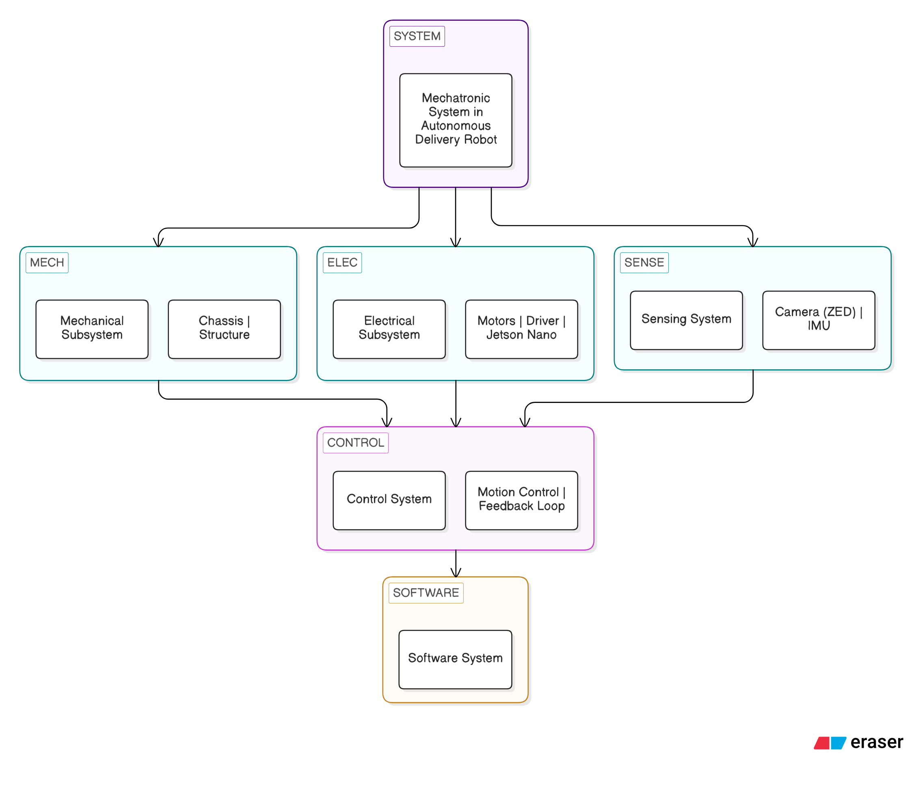 .
Figure 1.1: Block Diagram

1.4 Context And Motivation
The design and development of the proposed indoor autonomous delivery system are shaped by a set of practical conditions, constraints, and assumptions drawn from the target deployment environment. These factors collectively define the operational boundaries within which the system must function, and they directly inform the selection of design approaches and the overall system architecture.
The following points outline the context and motivation in a structured manner:
Environment Definition
- The system is designed for a structured indoor environment composed primarily of corridors and interconnected rooms. Robot motion is confined to navigable pathways, specifically corridor regions and room entry points, which form the traversable network across the deployment floor.
- The robot operates within corridor regions only. Room interiors and non-accessible areas of the floor are treated as non-navigable space and are excluded from path planning and localization computations.
- The operational area is restricted to a single floor of the building. This constraint eliminates the need for multi-floor localization schemes or any vertical navigation mechanism, simplifying the navigation problem without sacrificing practical utility for the intended application.
- The deployment environment exhibits a low ratio of navigable to total floor area. A substantial proportion of the map footprint corresponds to walls, room interiors, and structurally inaccessible regions that the robot will never traverse. This spatial characteristic has a direct bearing on map representation strategies and resource utilization.
Operational Conditions
- The environment is considered moderately dynamic in nature. The primary dynamic entities encountered during operation are humans moving through corridor spaces. Static obstacles include chairs, bags, bottles, and similar objects placed along pathways, along with occasional repositioning of items such as dustbins or racks. The system must handle both categories reliably without requiring full replanning in every case.
- Lighting conditions across the deployment floor are assumed to be stable and sufficient for vision-based sensing throughout operational hours. This assumption supports reliable performance of the onboard stereo camera, which depends on adequate ambient illumination for depth estimation and visual odometry.
- Real-time operation is a fundamental requirement. Localization, path planning, and motion control must execute continuously and in coordination throughout navigation. Any significant latency in one function propagates into degraded performance across the others, making computational efficiency a design-level concern rather than an optimisation afterthought.
System Constraints — Hardware and Computation
- The system is deployed on an embedded computing platform with constrained memory capacity and processing throughput. This imposes a practical ceiling on the computational complexity of algorithms that can be run concurrently, and it necessitates careful management of active data structures, particularly those associated with map representation and the navigation stack.
- The onboard hardware configuration, including the sensors and actuators selected for this platform, introduces inherent limits on sensing range, depth accuracy, and motor control precision. These hardware-level constraints bound the achievable localization accuracy and the minimum obstacle clearance that can be reliably maintained during navigation.
Mapping and Navigation Constraints
- A pre-built occupancy grid map of the deployment environment is available prior to operation. This allows the system to concentrate its onboard resources on localization and navigation rather than constructing or maintaining a map concurrently during a run, which would impose significantly higher computational and memory demands.
- Higher map resolution is preferred from a navigation accuracy standpoint, as finer grid cells allow more precise representation of corridor boundaries and obstacle positions. However, increased resolution directly raises memory consumption and expands the data structures that the path planner must operate over, creating a practical tradeoff between accuracy an d resource usage.
- Approaches that maintain a single global map covering the entire floor result in inefficient resource utilization for this type of environment. Because the robot occupies only a small region of the floor at any given time, the majority of the active map — and the associated planner data structures — corresponds to areas that are irrelevant to the current navigation task. This motivates a spatially partitioned map management strategy.
- Localization drift is a known and practical concern in vision-based navigation systems, particularly over extended travel distances. Errors in visual odometry accumulate over time, causing the estimated pose to diverge progressively from the true robot position. Without periodic correction, this drift can compromise path following and obstacle avoidance reliability, making drift correction a necessary component of the localization pipeline.
Task and Usage Context
- The system is designed for repeated and structured operational tasks, specifically the transfer of materials between predefined pickup and dropoff locations within the floor. This task profile demands consistent and predictable navigation behaviour across successive runs, as variability in path execution or localization quality would directly affect the reliability of the delivery operation.
Safety and Interaction Requirements
- The robot operates in a shared environment alongside building occupants, placing a firm requirement on safe navigation behaviour. The system must maintain reliable obstacle detection and avoidance at all times, and its motion must remain controlled and predictable in the vicinity of humans to prevent conflict or hazard during normal corridor use.
- Operator interaction with the system is required during deployment. The platform must support task assignment and real-time mission monitoring through a user interface, allowing an operator to dispatch delivery tasks, track the robot's progress, and intervene if required without direct physical access to the robot.
Scalability and Design Direction
- Scalability is considered at the system architecture level from the outset. The design approach allows the navigation framework to be extended to larger indoor environments, additional floor areas, or increased numbers of delivery points without requiring structural changes to the core navigation stack. New zones can be incorporated by adding map tiles and updating the configuration, making the system extensible in proportion to the scope of the deployment.
These conditions collectively define the operational boundaries of the proposed system and motivate the specific design choices adopted throughout its development.
1.5 Contribution and Significance
The proposed work contributes to the development of efficient and practical indoor autonomous navigation systems by addressing specific limitations that arise in conventional approaches when deployed under real-world resource constraints. The contributions span system design, implementation, and application, and are grounded in decisions made in direct response to the operational conditions described in the preceding section.
A primary contribution of this work lies in the adoption of a spatially partitioned map management strategy for indoor navigation on an embedded computing platform. Rather than relying on a single global occupancy grid that covers the entire floor, or on computationally demanding real-time mapping techniques that require simultaneous map construction during navigation, the system uses a pre-built map that is loaded and managed selectively at runtime. Only the portion of the map relevant to the robot's current location is held active in memory at any given time, reducing both the memory footprint of the navigation stack and the computational load on the path planner. This approach allows the system to maintain reliable localization and navigation performance while operating within the constraints of an embedded platform with limited processing and memory resources.
The work also contributes at the application level by implementing end-to-end autonomous material transfer between predefined pickup and dropoff locations within an indoor floor. This constitutes a functional service robotics capability in an institutional setting, demonstrated within an academic building environment. The deployment establishes a working reference for similar applications in offices, laboratories, and other structured indoor facilities where automated item delivery between fixed points can reduce manual effort. The inclusion of a user interaction interface extends the practical utility of the system by allowing non-technical users to assign delivery tasks and monitor operational status without requiring direct engagement with the underlying software stack.
From a scalability standpoint, the architecture is designed to accommodate extension to larger environments without requiring structural modification to the core navigation framework. Additional floor zones can be incorporated by supplying new map tile files and updating the configuration parameters, while the switching logic and navigation stack remain unchanged. This property makes the system adaptable to deployment scenarios involving more extensive corridor networks or multiple zones, and reduces the engineering effort required for each new deployment beyond the initial setup.
In terms of technical novelty, the system is differentiated by its focus on the efficient use of pre-built map data within corridor-dominated environments. Indoor spaces of this type are characterised by a low ratio of navigable to total floor area, with the majority of the map footprint occupied by walls, room interiors, and other permanently non-navigable regions. Conventional approaches that maintain a full global map allocate memory and planner resources uniformly across the entire map extent, including regions the robot will never enter. The approach adopted in this work avoids that inefficiency by aligning the active map coverage with the robot's actual traversal region, resulting in measurable reductions in planner memory usage and costmap size without degrading navigation accuracy. This represents a practical alternative to standard monolithic map approaches for this class of environment.
The significance of the work extends across several levels. At the technical level, the system demonstrates a concrete method for improving resource efficiency in indoor navigation stacks deployed on embedded hardware, with quantified reductions in memory consumption and costmap size reported through benchmarking. At the institutional level, the implementation provides a functional foundation for autonomous delivery systems within campus environments, where the structured layout of corridors and rooms is well suited to this approach. At the individual level, the work involved the integration of mechanical design, embedded hardware, real-time software, and user interface development into a single operational system, contributing to practical experience across the constituent disciplines of mechatronics engineering.
The proposed system represents a considered step toward practical and scalable indoor autonomous navigation, with contributions that are grounded in real deployment constraints and relevant to both applied robotics research and operational service robotics in institutional settings.

1.6 Overview of the Project
The proposed project addresses the development of an autonomous indoor delivery robot intended to operate within a structured, corridor-based indoor environment. The system is designed to carry out material transfer tasks between predefined pickup and dropoff locations on a single floor, with the primary goal of demonstrating consistent and reliable autonomous operation under real-world deployment conditions.
The development of this system required the integration of mechanical, electronic, and software components into a single, coordinated platform. The mechanical foundation is based on an existing mobile robot chassis that was adapted to accommodate payload transport, with structural modifications made to support the intended material transfer function while preserving the platform's stability and maneuverability. The electrical and electronic subsystems provide the means for motor actuation, onboard sensing, and hardware-level system control, forming the physical layer through which all software-driven commands are executed. The software components manage the higher-level functions of the system, including localization against a pre-built environment map, path planning to assigned goal locations, motion control during navigation, and system-level coordination across the active subsystems.
Beyond the development of individual components, the project involved multiple structured stages covering system setup, subsystem integration, and end-to-end validation. Each stage was carried out in a deliberate sequence to ensure that dependencies between subsystems were resolved before integration testing began, and that observed issues at each stage were addressed prior to progression. This structured approach was necessary given the interdependence of the mechanical, electrical, and software layers, where a fault or misalignment in one subsystem has direct consequences for the performance of the others.
To clearly represent the sequence of development activities undertaken in this work, an illustrative workflow is presented in the following section. This workflow identifies the major stages involved in building and deploying the complete system, proceeding from the initial analysis of the deployment environment through hardware assembly, software development, subsystem integration, and culminating in real-world testing and validation of the operational system.

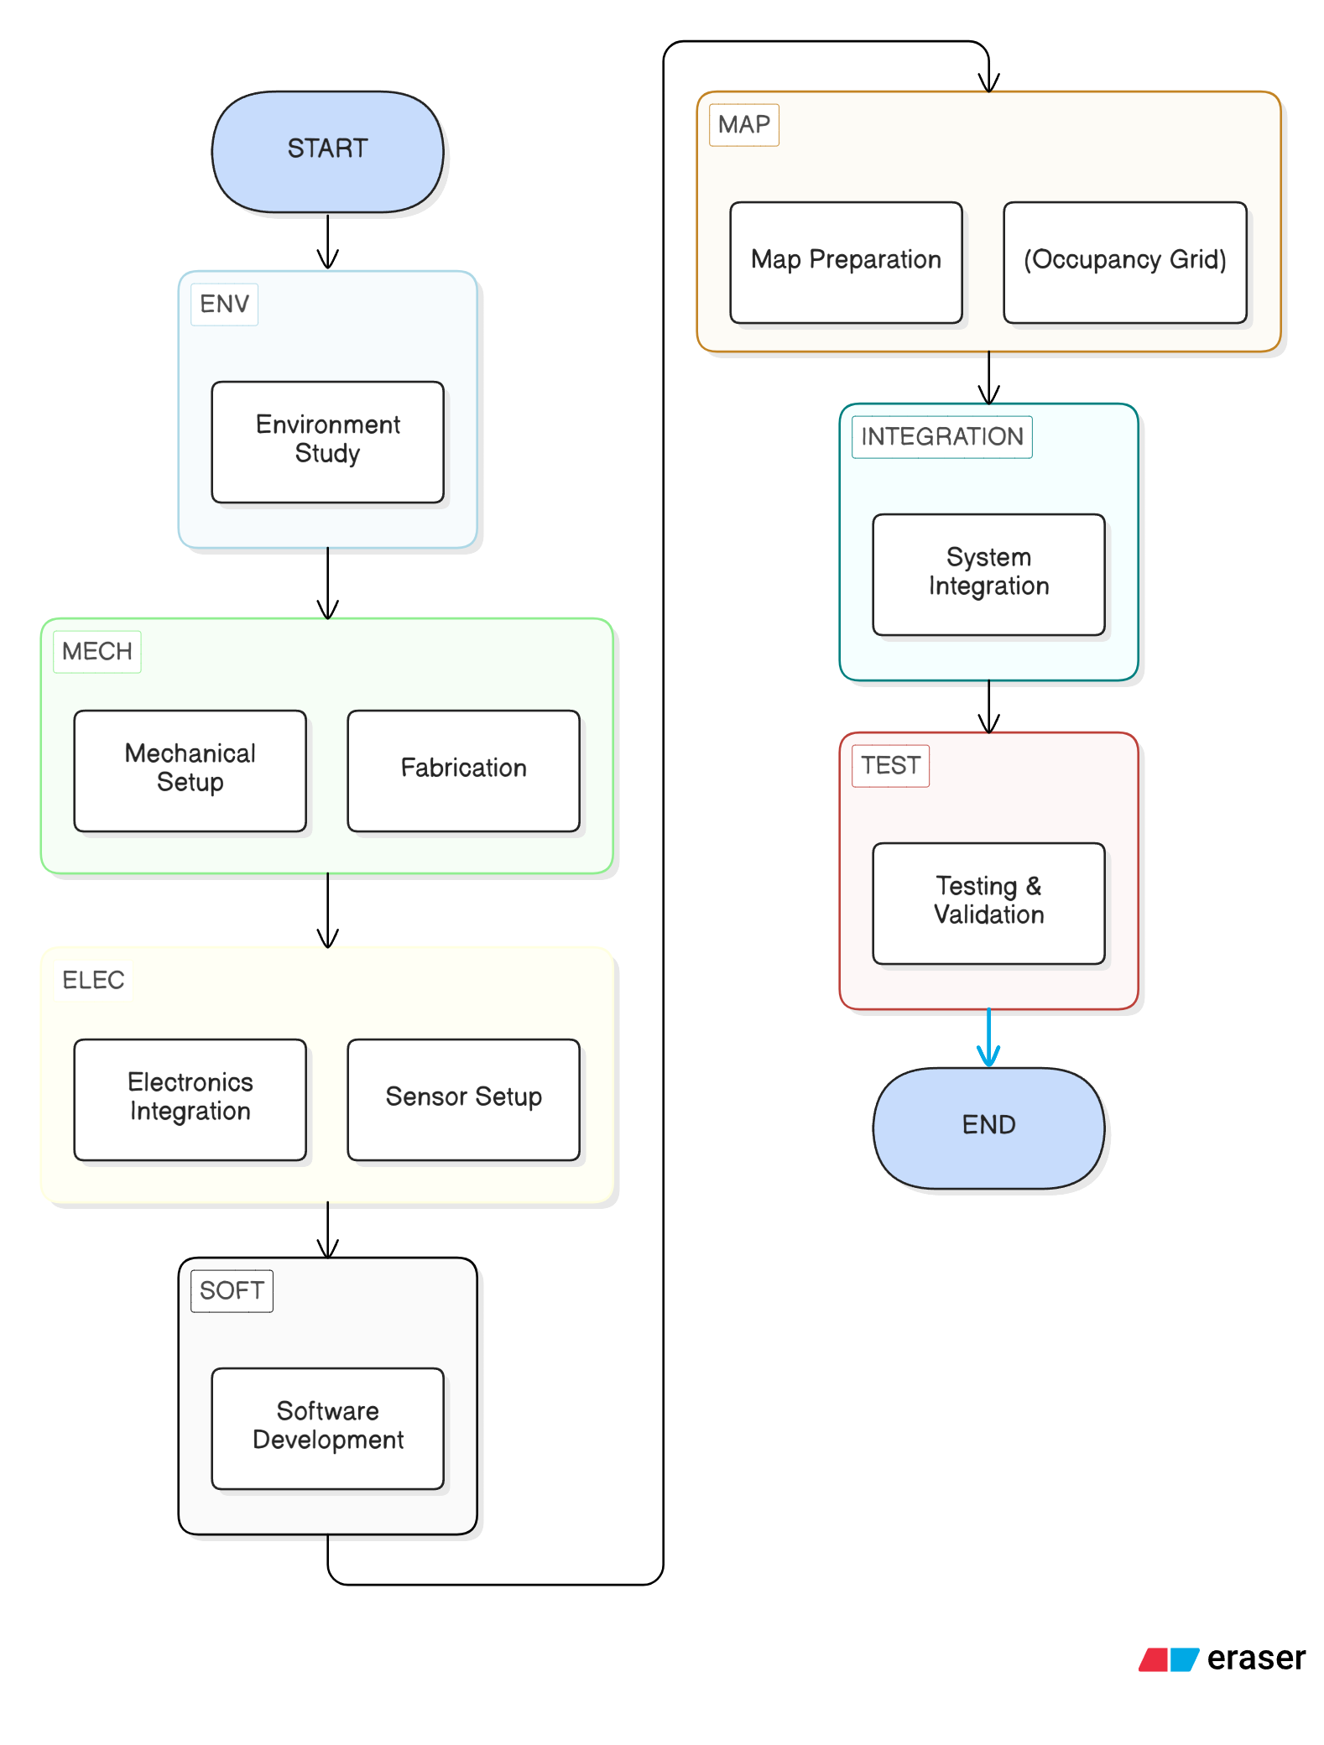
Chapter 2 Literature Survey

[Provide an introductory paragraph for the literature survey. Describe the scope of the survey, the databases or sources searched, and the time period covered.]

2.1 Review of [Topic Area 1]
[Author Last Name] et al. ([Journal/Conference Name], [Year]) in the paper titled "[Paper Title]" [describe what the authors did, their methodology, key findings, and conclusions. Write in third person and past tense. Do not copy text from the paper—paraphrase in your own words.]
[Continue discussion of this paper or transition to the next paper in this sub-section.]

2.2 Review of [Topic Area 2]
[Author Last Name] and [Author Last Name] ([Journal Name], [Year]) in the paper titled "[Paper Title]" [describe what the authors proposed, the system or method developed, and their results.]
[Add more papers reviewed under this sub-topic. Each paper should have its own paragraph.]

2.3 Review of [Topic Area 3]
[Describe papers reviewed in this category. Provide sufficient detail including problem addressed, approach taken, and outcomes achieved.]

2.4 Review of [Topic Area 4]
[Describe additional papers reviewed. Cover at least 10-15 papers total across all sub-sections of the literature survey to meet the minimum page requirement.]

2.5 Summary of Literature Survey
[Provide a summary paragraph consolidating the findings from the literature survey. Identify the research gaps, limitations of existing works, and how your project addresses those gaps.]
[State clearly what is novel or different about your approach compared to prior work.]

Chapter 3 [Chapter Title – Guide's Decision]

[Provide an introductory paragraph for this chapter. Describe what this chapter covers and how it contributes to the overall project.]

3.1 [Sub-Heading 1 – Title Case]
[Write the content for this section here. All text should be 12pt Times New Roman, 1.5 line spacing, justified, with 6pt spacing before and after paragraphs.]
[Continue with additional paragraphs as needed. Each new idea or concept should begin a new paragraph.]

3.1.1 [Sub-Sub-Heading – Title Case, Not Bold]
[Write the content for this sub-section. Sub-sub-headings are 12pt, not bold, Title Case.]
[Insert tables and figures as needed. Tables should have their caption at the top-left; figures should have their caption centered below.]

Table 3.1: [Table Title – Placed at Top Left of Table]
Description | Specification
[Parameter 1] | [Value / Unit]
[Parameter 2] | [Value / Unit]
[Parameter 3] | [Value / Unit]

3.1.2 [Sub-Sub-Heading – Title Case, Not Bold]
[Write content here. For inserting a figure, place the image below the relevant text and add the caption centered below the figure as shown below.]
[INSERT FIGURE HERE]
Figure 3.1: [Figure Caption – Centered Below Figure]

3.2 [Sub-Heading 2 – Title Case]
[Write content for this section. Continue numbering sub-sections as 3.2.1, 3.2.2 etc. if sub-sub-headings are needed.]

3.2.1 [Sub-Sub-Heading]
[Write content here.]

3.2.2 [Sub-Sub-Heading]
[Write content here.]

3.3 [Sub-Heading 3 – Title Case]
[Write content for this section.]

3.4 [Sub-Heading 4 – Title Case]
[Write content for this section.]

3.5 [Sub-Heading 5 – Title Case]
[Write content for this section.]

Chapter 4 [Chapter Title – Guide's Decision]

[Provide an introductory paragraph for this chapter.]

4.1 [Sub-Heading 1 – Title Case]
[Write content for this section.]

4.1.1 [Sub-Sub-Heading]
[Write content here.]

4.1.2 [Sub-Sub-Heading]
[Write content here.]

4.2 [Sub-Heading 2 – Title Case]
[Write content for this section.]

4.2.1 [Sub-Sub-Heading]
[Write content here.]

4.3 [Sub-Heading 3 – Title Case]
[Write content for this section.]

4.3.1 [Sub-Sub-Heading]
[Write content here.]

4.4 [Sub-Heading 4 – Title Case]
[Write content for this section.]

4.5 [Sub-Heading 5 – Title Case]
[Write content for this section.]

4.6 [Sub-Heading 6 – Title Case]
[Write content for this section.]

Chapter 5 [Chapter Title – Guide's Decision]

[Provide an introductory paragraph for this chapter.]

5.1 [Sub-Heading 1 – Title Case]
[Write content for this section. This chapter is left to the guide's decision on content and structure.]

5.1.1 [Sub-Sub-Heading]
[Write content here.]

5.1.2 [Sub-Sub-Heading]
[Write content here.]

5.2 [Sub-Heading 2 – Title Case]
[Write content for this section.]

5.2.1 [Sub-Sub-Heading]
[Write content here.]

5.3 [Sub-Heading 3 – Title Case]
[Write content for this section.]

5.4 Result and Discussion
[Present and discuss the results obtained from experiments, simulations, or analyses. Use tables and figures to support the discussion. Compare results with existing literature where applicable.]
[Insert result tables here using the same table format shown in Chapter 3.]
[INSERT RESULT FIGURE / GRAPH HERE]
Figure 5.1: [Result Figure Caption]

Chapter 6 Conclusion and Scope for Future Work

6.1 Conclusion
[Write the conclusion of your project. Summarize the work done, the objectives achieved, and the key outcomes of the project. Be specific about what was accomplished and what results were obtained.]
[Highlight the significance of your project findings. State how the results address the challenges and needs outlined in Chapter 1. Make sure conclusions are supported by the results presented in earlier chapters.]
[State any limitations of the current work that should be acknowledged.]

6.2 Scope for Future Work
[Describe possible future enhancements and extensions of this project. Suggest improvements that could be made to the design, algorithm, methodology, or implementation based on the limitations identified.]
[Propose future research directions, additional experiments, or applications that could be explored building upon this work.]
[Mention any emerging technologies or methods that could be incorporated in future iterations of the project.]

References

[Author Last Name], [Initials]. and [Author Last Name], [Initials]. ([Year]) '[Title of the Article]', [Journal/Conference Name], Vol.[X], No.[X], pp.[XXX-XXX].
[Author Last Name], [Initials]. ([Year]) '[Title of the Article]', [Journal Name], Vol.[X], No.[X], pp.[XXX-XXX].
[Author Last Name], [Initials]. ([Year]) [Title of Book], [Edition], [Publisher], [Place of Publication].
[Author Last Name], [Initials]. et al. ([Year]) '[Paper Title]', Proceedings of [Conference Name], [Place], [Month Year], pp.[XXX-XXX].
[Author Last Name], [Initials]. ([Year]) '[Paper Title]', [Journal Name], Vol.[X], Issue [X], pp.[XXX-XXX].

[Website Name] – [Description], [URL] (Accessed: [Month Year]).

Note: List all references in alphabetical order by first author's last name. Use single line spacing with 6pt space before each new reference. Internet references must be placed at the end, arranged alphabetically by website name.

Appendix A [Title – e.g., Programming Code]

[Include supplementary material here such as controller programming code, calculation sheets, data sheets, experimental raw data, or any supporting material not included in the main chapters.]

[If including programming code, use Courier New 10pt font for the code block. Example:]

void setup() {
// Initialize pins and modules
}

void loop() {
// Main program logic here
}

Appendix B [Title – e.g., Efficiency Calculations]

[Include additional supplementary material here such as detailed calculations, derivations, experimental setups, calibration data, or manufacturer data sheets.]

B.1 [Calculation Sub-Section Title]
[Write detailed calculations or derivations here. Show all formulas, intermediate steps, and final results clearly.]

B.2 [Data Sheets / Additional Material]
[Include data sheets, manufacturer specifications, or any other reference material that is too detailed to include in the main chapters but is essential for completeness of the report.]

